Database Systems Class Project Final Report

CSCI 3700/6070 Database Systems Spring 2020

**IMDB WEB APPLICATION USING THE MVC ARCHITECTURE**

A PROJECT REPORT

Presented to the Department of Computer Science

Auburn University at Montgomery

In Partial Fulfillment

of the Requirements for the Degree

Master of Science in Computer Science

By

Ajay Saradhi Reddy Chilukuri

Jhansi Alugubelly

Sri Datta Harshini Singu

Nagarjuna Sriramaneni

# Introduce your database design (e.g. ER diagram, database schema etc.)

**Database:** It is responsible for storing and retrieving the data. The database is a separate entity that is stored externally outside the programming workspace and it is usually managed by 3rd party software such as MySQL or Oracle, the two most prominent database tools that are being used in software development. We used the Microsoft SQL Server and Microsoft SQL Server Management Studio (SSMS) Tool at Database side.

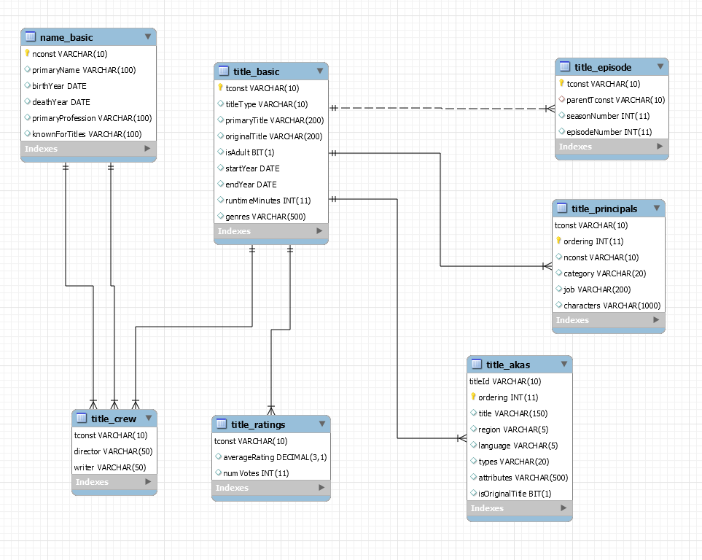

# Introduce your application design (e.g. MVC model, UML mode, etc.)?

The Model-View-Controller (MVC) architectural pattern is one of the most useful design patterns for developing applications. Primarily, the MVC architecture aims to separate business logic, data model, and user interface.

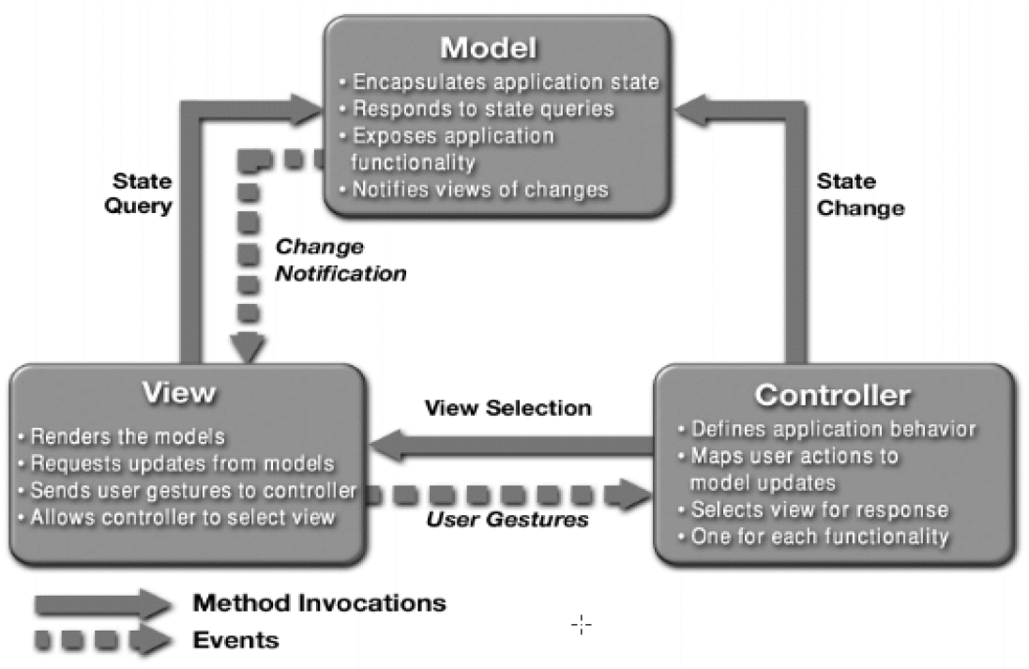

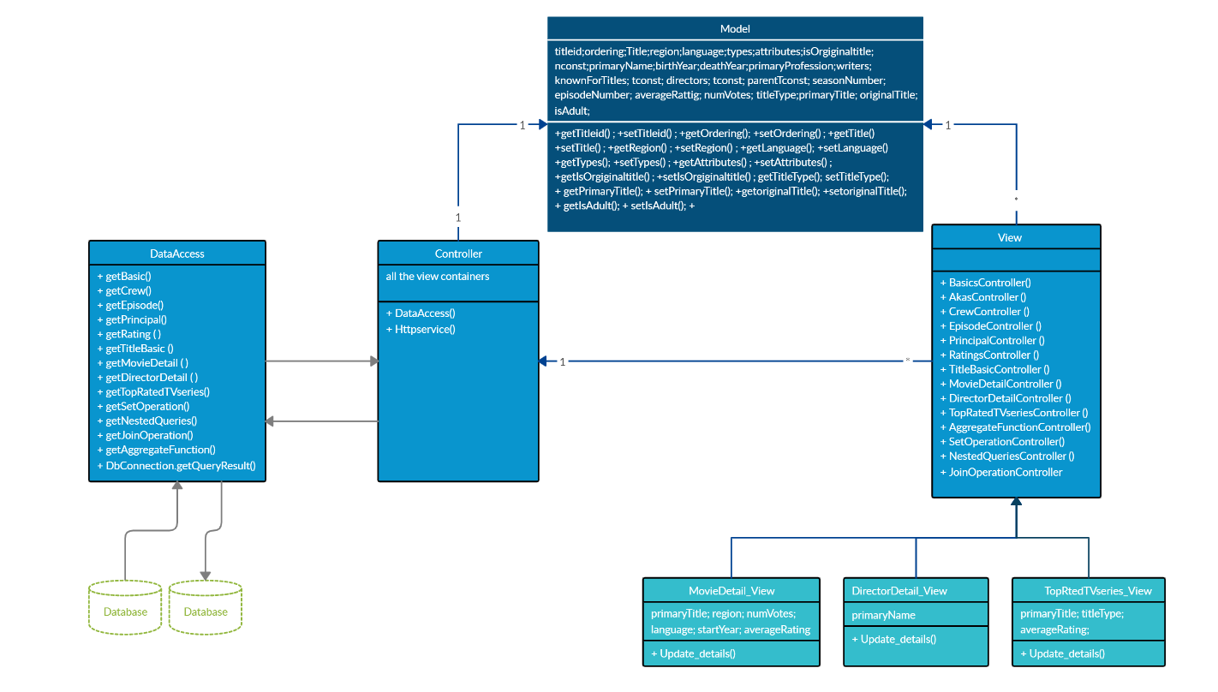

# List any technology that is not mentioned in the project description (e.g. Indexing, Caching, etc.)

We used below extra technologies in our class project

1. Apache Tomcat

2. Microsoft SQL Server

3. Designed Queries using Views and Stored Procedures.

**APACHE TOMCAT:** The Apache Tomcat software is an open source implementation of the Java Servlet, Java Server Pages, Java Expression Language and Java WebSocket technologies.

Apache Tomcat is usually used as a Servlet Container even though Tomcat has a fully functional HTTP Server to serve static content. In most of production, Tomcat is used in conjunction with Apache HTTP Server where Apache HTTP Server attends static content like html, images etc., and forwards the requests for dynamic content to Tomcat.

Java Server Pages (JSP) is a server-side technology for developing dynamic web pages. This is mainly used for implementing presentation layer (GUI Part) of an application. A JSP page consists of HTML tags and JSP tags. It provides some additional features such as Expression Language, Custom Tags, etc.

Java Servlets are programs that run on a Web or Application server and act as a middle layer between a requests coming from a Web browser or other HTTP client and databases or applications on the HTTP server. Using Servlets, you can collect input from users through web page forms, present records from a database or another source, and create web pages dynamically.

# Please attach your codes (application) or a GitHub link to your project along with this report.

**GIT HUB LINK:** <https://github.com/ajayreddy222/CSCI6070/>

# Individual tasks

|  |  |
| --- | --- |
| **Student Name** | **Major tasks** |
| AJAY SARADHI REDDY CHILUKURI | Dividing the tasks to the team Members.  Done coding part i.e. MVC Model Design and Helping other team members in the coding part.  Been a part in the documentation for the final report.  Worked on Implementing the Extra features  Designed few queries by using stored procedure. |
| JHANSI ALUGUBELLY | Setting up the environment for the project i.e. Downloading the given datasets for the project from online database, installing Microsoft SQL server and SSMS. Converting the downloaded datasets which are in (TSV) formatted files to (CSV) formatted files. Created the tables and inserted the data into the tables.  Designed few queries by using Views.  Been a part in the documentation for the final report. |
| SRI DATTA HARSHINI SINGU | Designing the required queries for the questions in project i.e. (Aggregate functions and Set Operations)  Documentation for submitting document for the group project first deliverable.  Done UML Diagram for the Project.  Done coding for the Database connection. |
| NAGARJUNA SRIRAMANENI | Converting the downloaded datasets which are in (TSV) formatted files to (CSV) formatted files and handling the null values during importing.  Designing the required queries for the questions in project. i.e. (Join Operations and Nested Queries).  Done Database Schema diagram for the project.  Created the tables and inserted the data into the tables. |

# Functions (take screenshots from your apps, not from MySQL) (Section 2.3)

* 1. Show the information of movies (Title, Region, Language, Year, Rating, Votes) which have average rating greater than 7 and number of votes greater than 1000.

**Screenshot:**

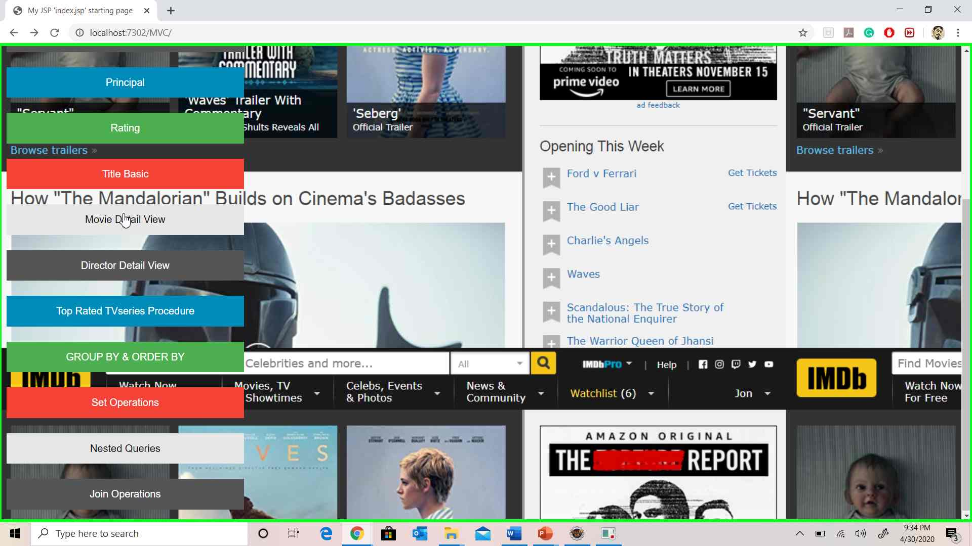

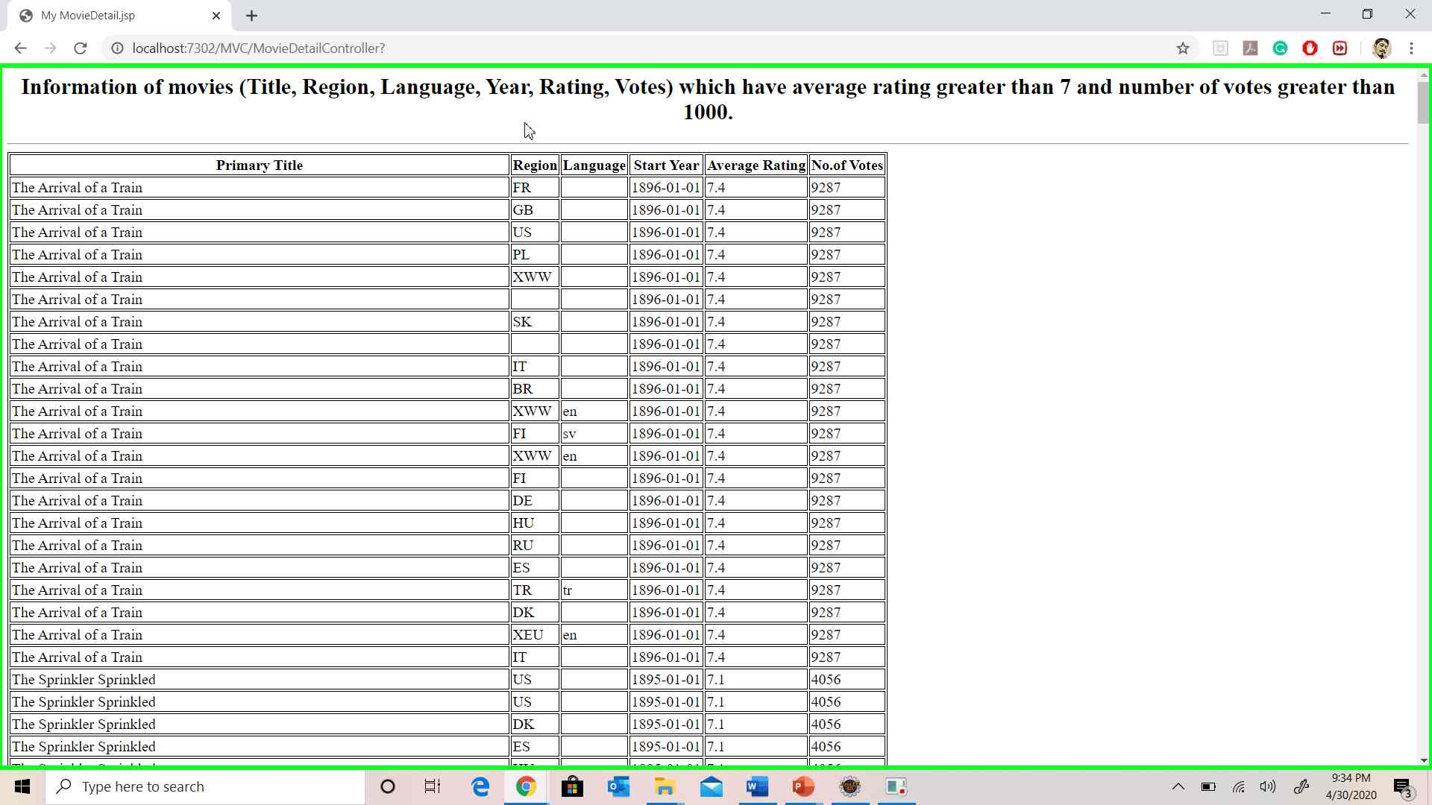

* 1. Show the names of persons who have directed more than 10 movies.

**Screenshot:**

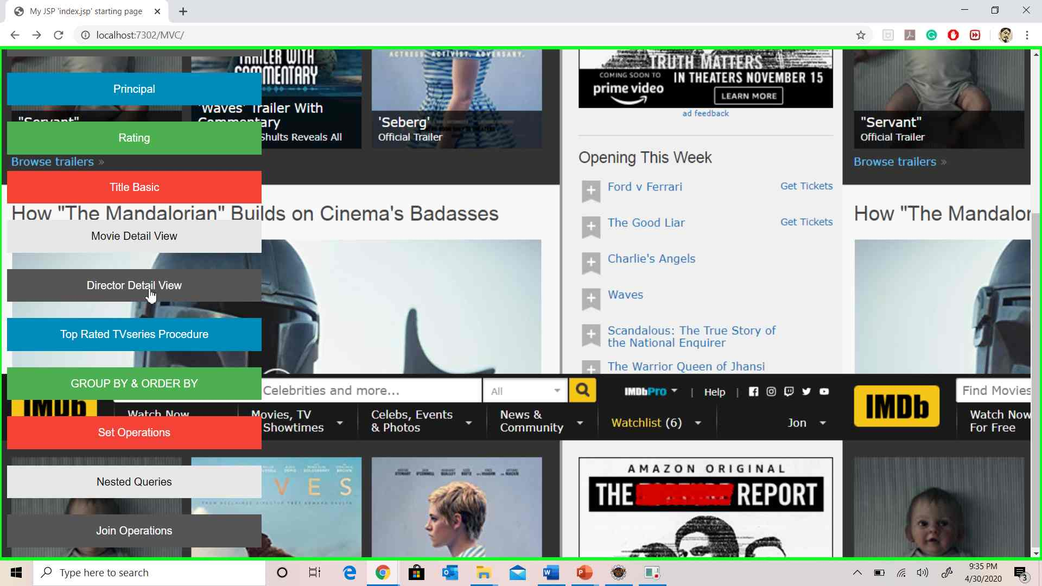

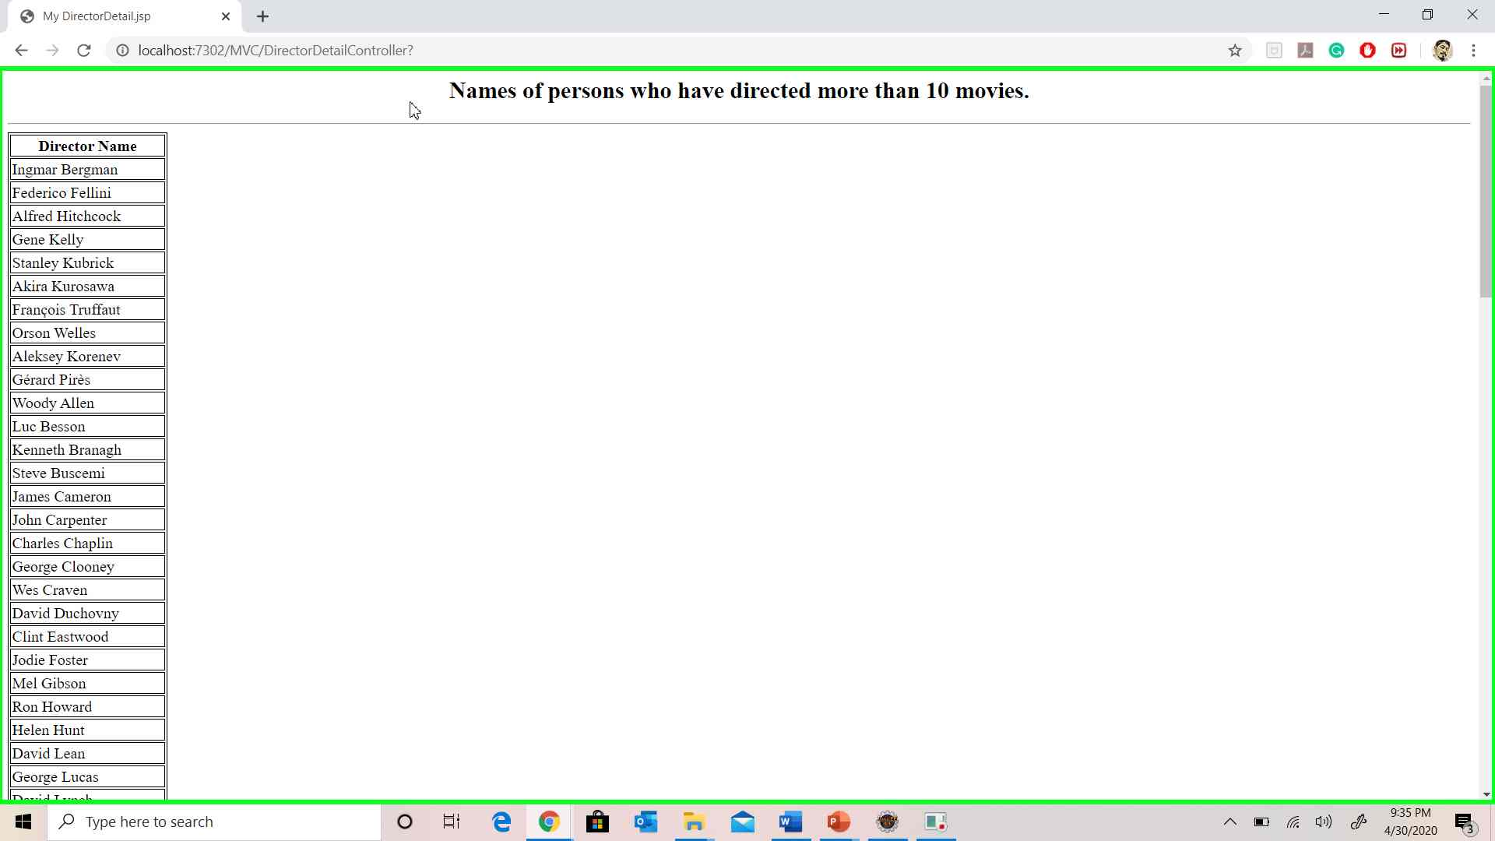

* 1. Show the top 10 TV series (more than 1 season) which most average ratings.

**Screenshot:**

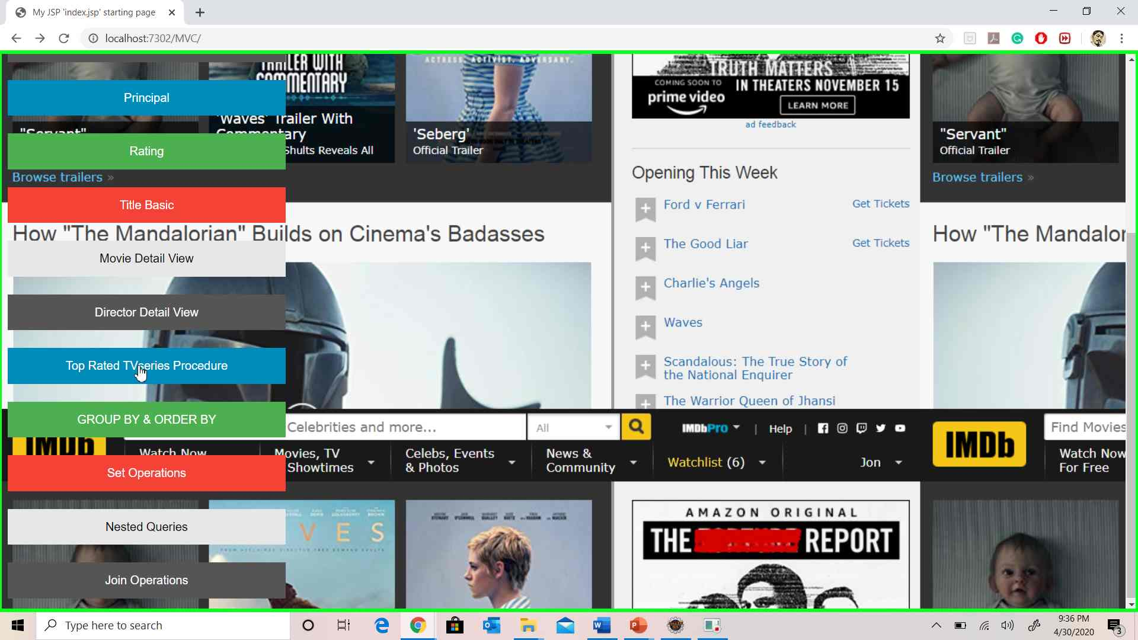

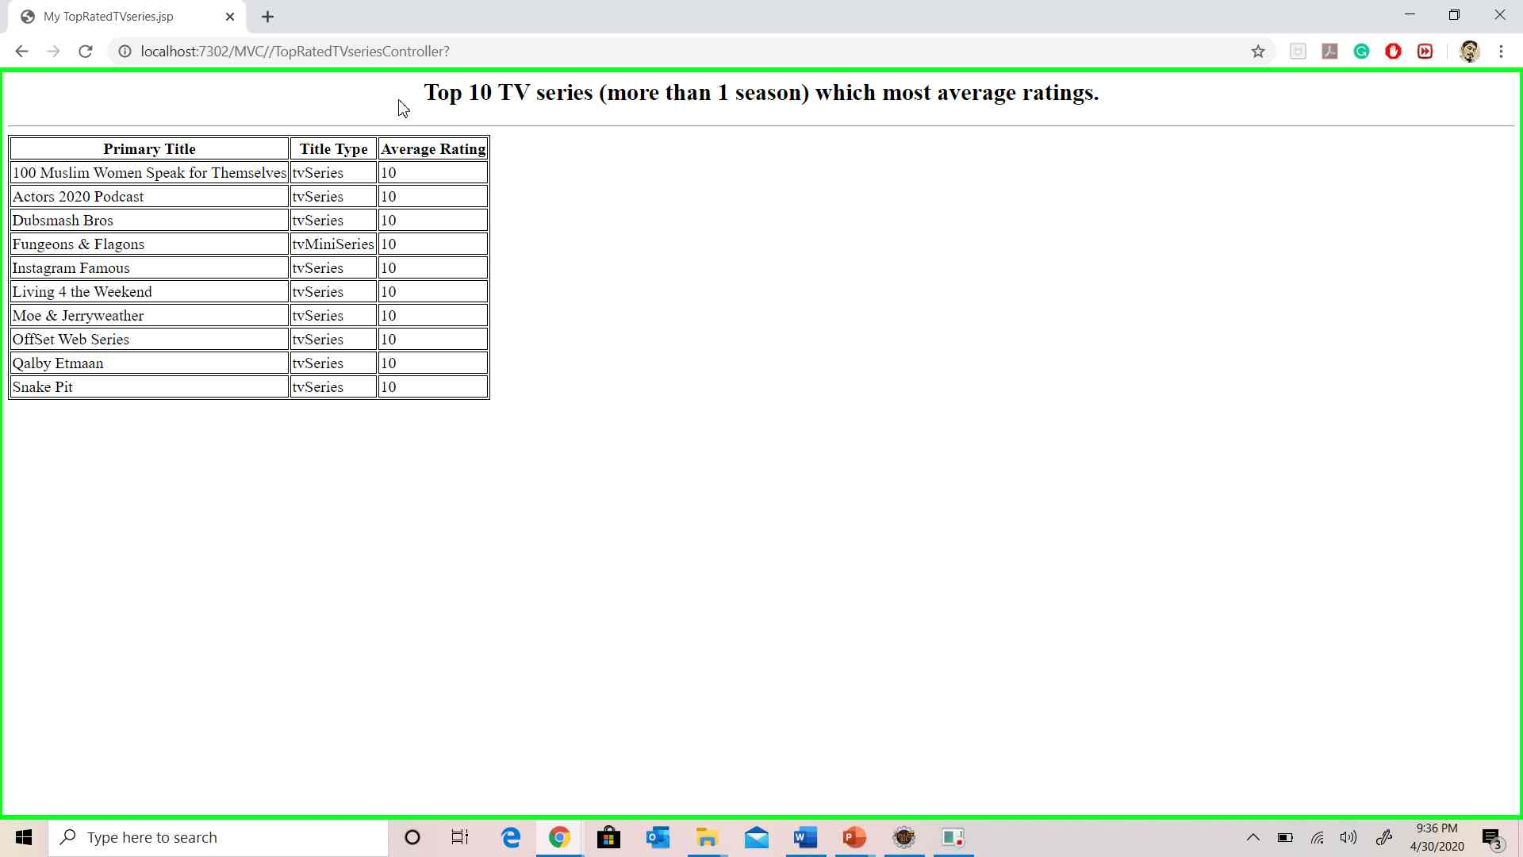

* 1. Optional 4 more queries which satisfy
     1. Use aggregate functions, “group by” and “order by”.
     2. Use set operations.
     3. Use nested/sub queries (either in SELECT clause, FROM clause or WHERE clause).
     4. Use JOIN operations.

**GROUP BY & ORDER BY Screenshot:**

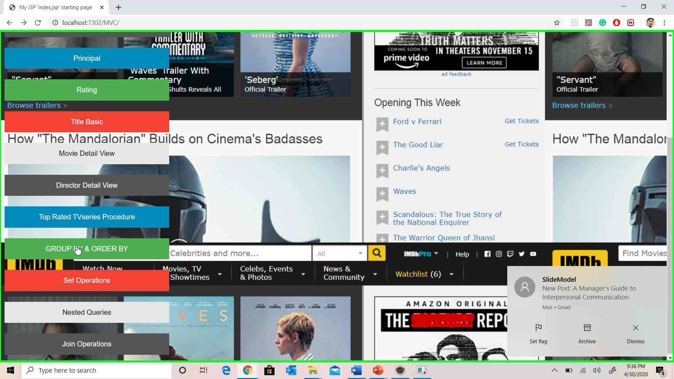

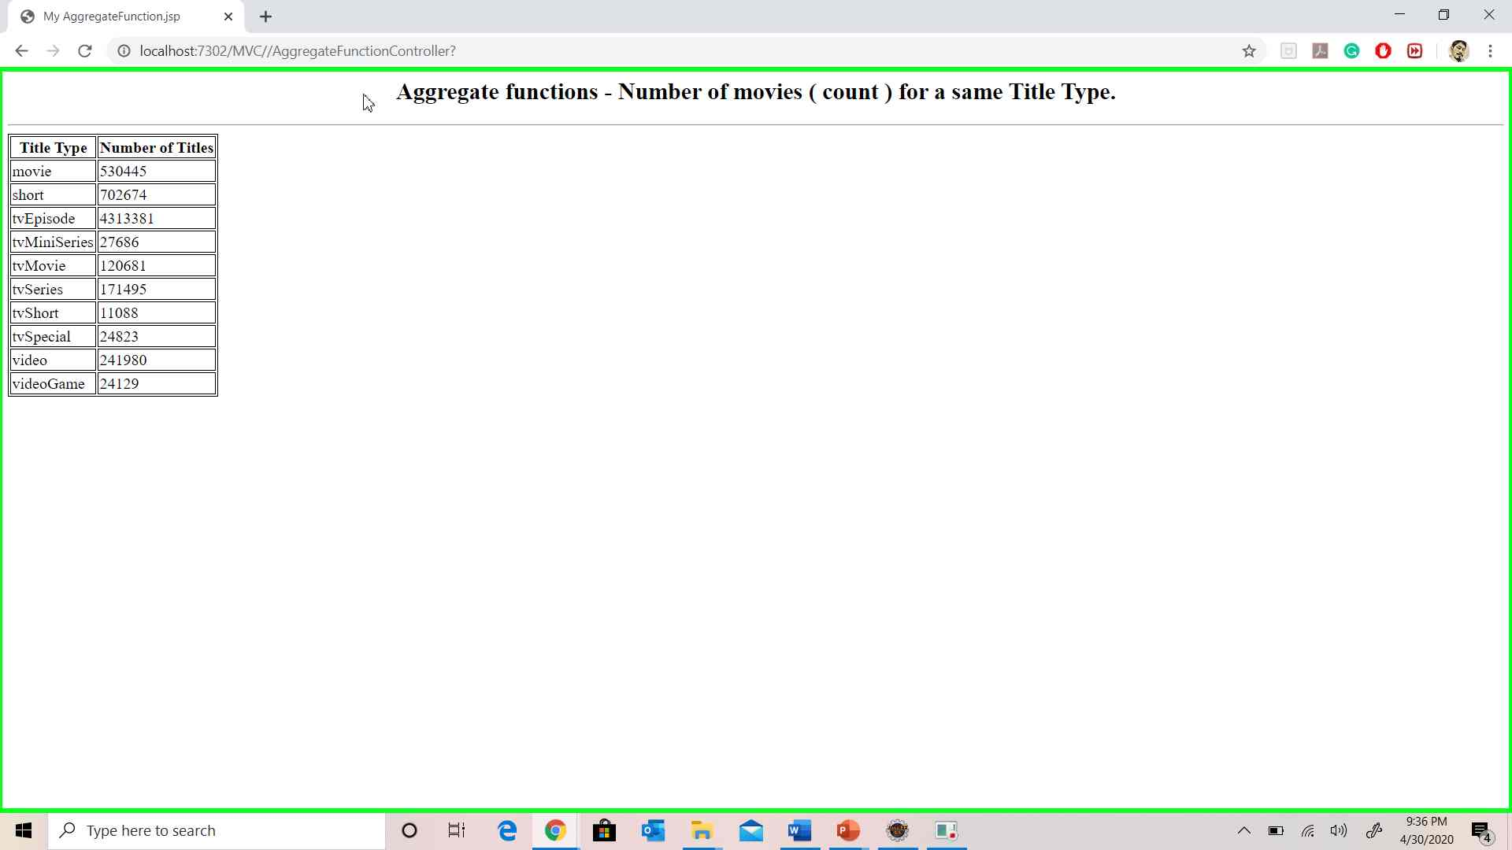

**Set Operations Screenshot:**

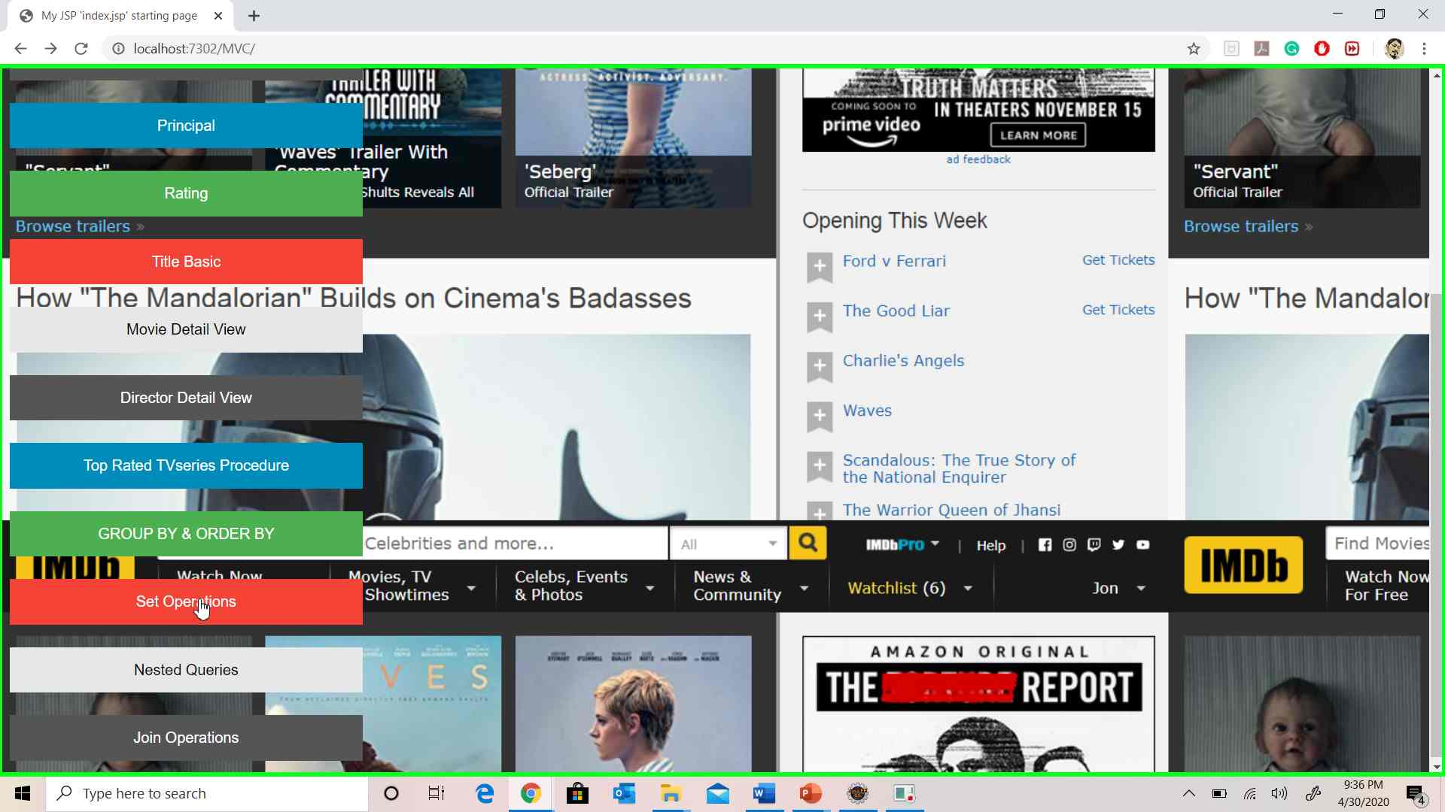

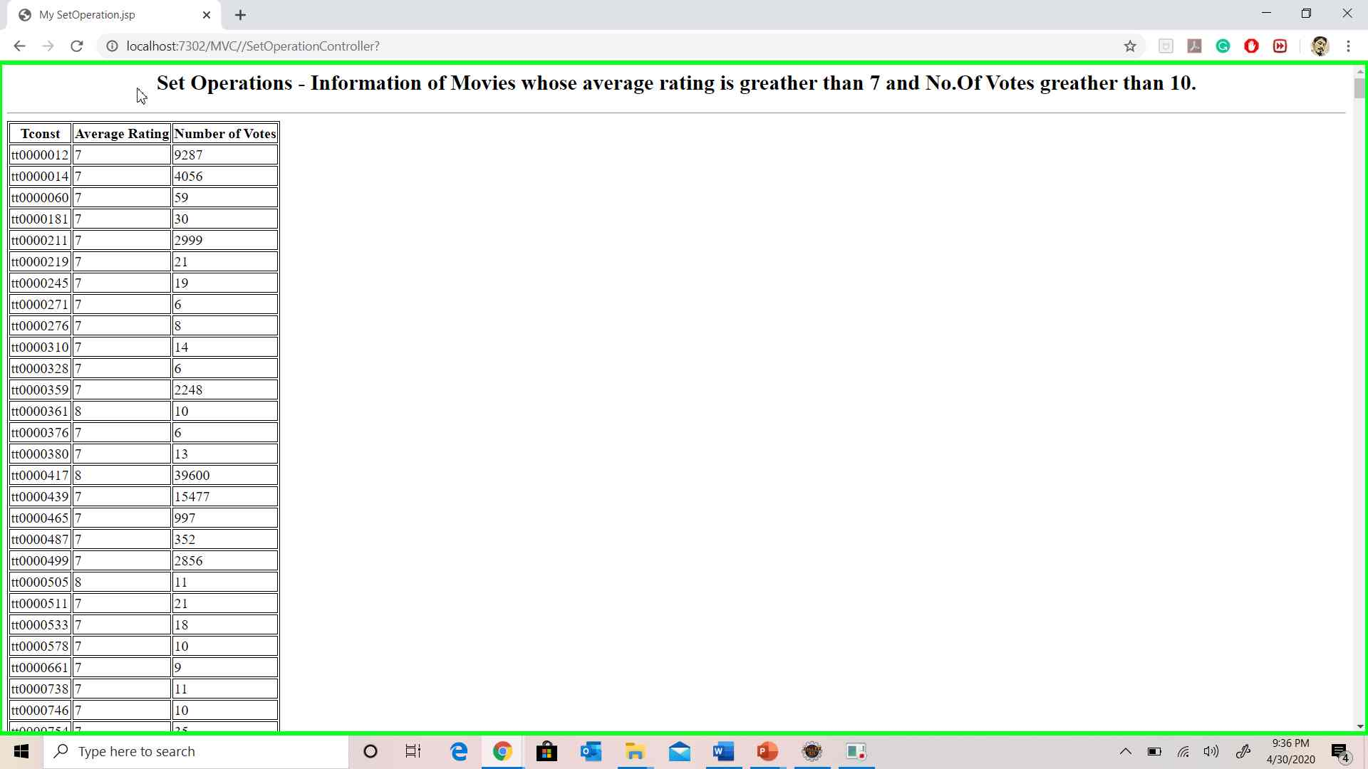

**Nested Queries Screenshot:**

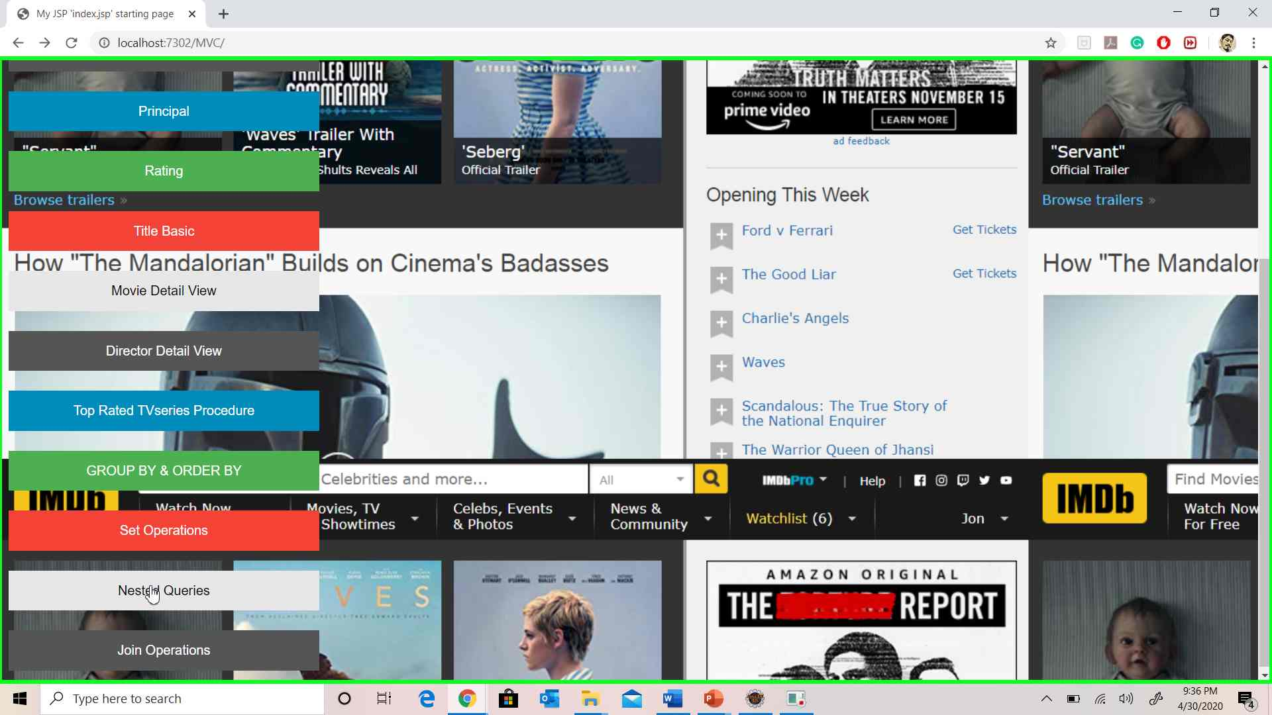

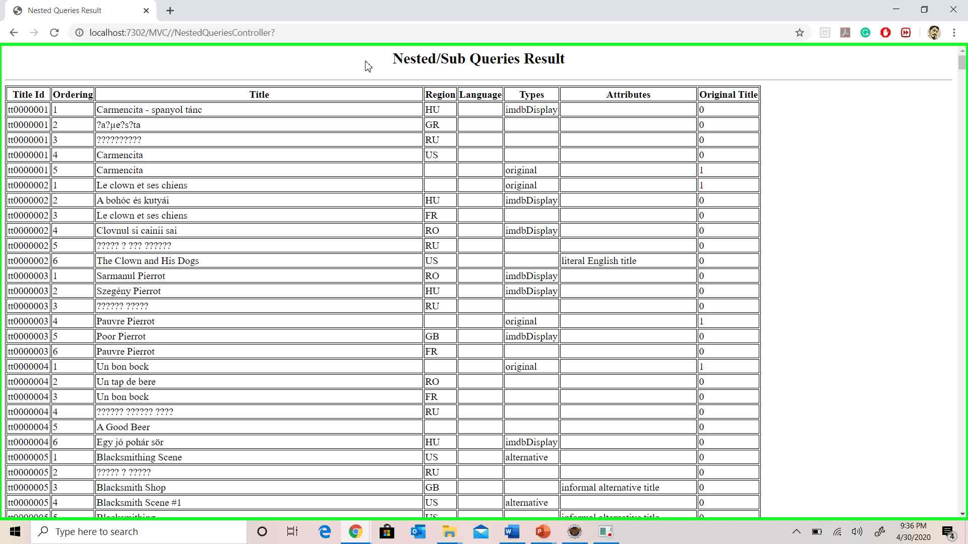

**Join Operations Screenshot:**

